1. Consultation Service
2. General Consultation Service
3. 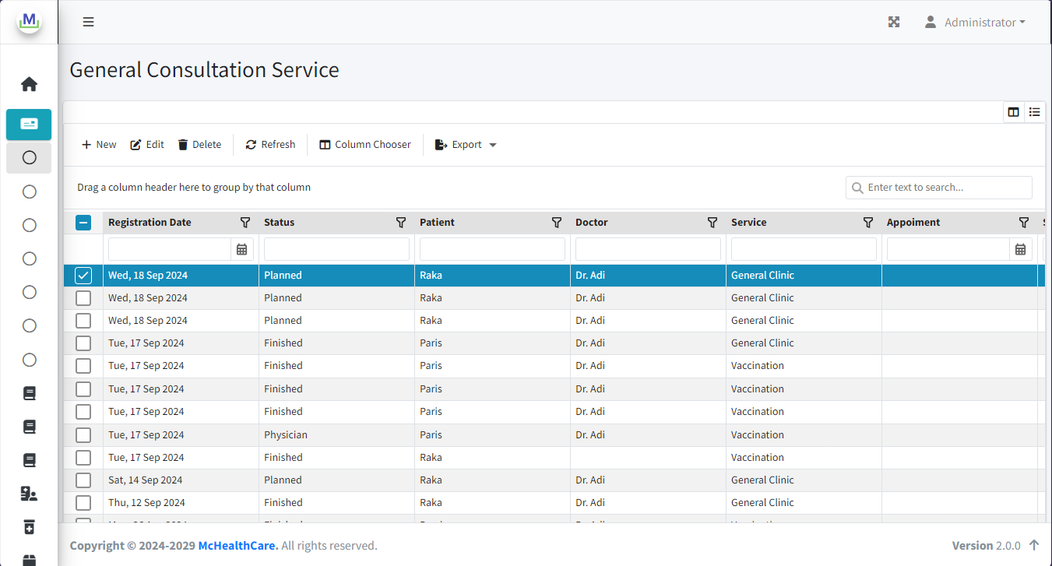List Data
4. 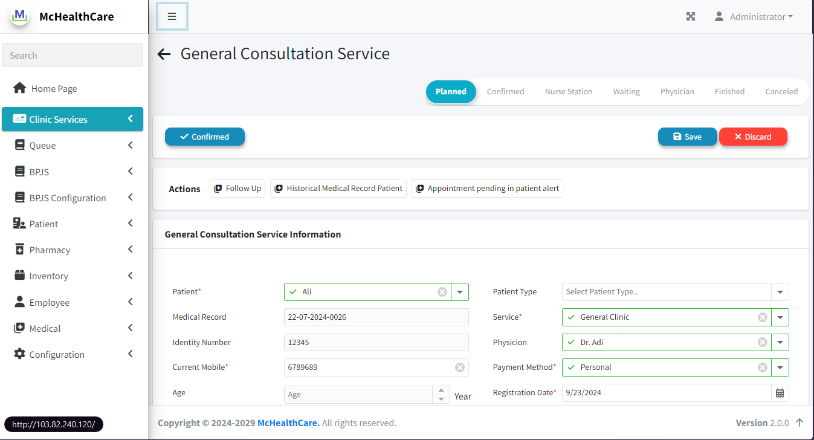Form Cosnultation Service (Add/Edit)

